

Lab No. 1
Write a C program to find the growth in national consumption for five years using Distributed Lag Model given below:
I = 2 + 0.1 Y-1
Y = 45.45 + 2.27 (I +G)
T = 0.2 Y
C = 20 + 0.7 (Y – T)
Assume the initial value of Y₋₁ is 80 and take the governmental expenditure in the 5 years to be as follows:
Year | G
1 | 20
2 | 25
3 | 30
4 | 35
5 | 40

Source Code:
#include <stdio.h>
#include <conio.h>
int main()
{
float Y_1, Y, I, T, C[5];
float G[5] = {20, 25, 30, 35, 40};
int i;
printf("Enter initial value of lagged variable Y_1:");
scanf("%f", &Y_1);
printf("\nThe growth in consumption is given following tables:\n");
printf("\nYear \t \t Consumption\n");
for (i = 0; i < 5; i++)
{
I = 2 + 0.1 * Y_1;
Y = 45.45 + 2.27 * (I + G[i]);
T = 0.2 * Y;
C[i] = 20 + 0.7 * (Y - T);
printf("\n %d \t \t %.2f", i + 1, C[i]);
Y_1 = Y;
}
return 0;
}

Output:
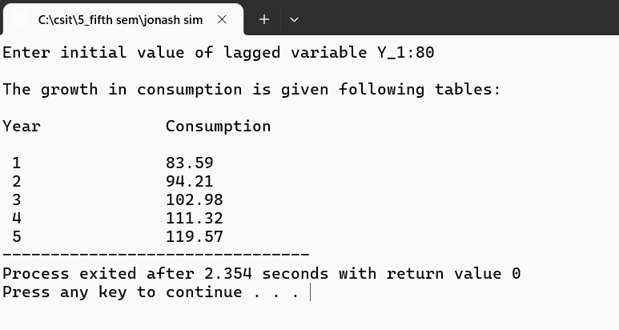



Lab No. 2
Customers arrive in a bank according to a Poisson's process with mean inter arrival time of 10 minutes. Customers spend an average of 5 minutes on the single available counter, and leave.
Write a program in C to find:
I. Probability that a customer will not have to wait at the counter.
II. Expected number of customers in the bank.
III. Time can a customer expect to spend in the bank
Source Code:
#include <stdio.h>
#include <conio.h>
int main()
{
float l, m, e;
float p, et;
printf("Enter Inter arrival time of customers per hours:");
scanf("%f", &l);
printf("\nEnter The average time spent by cutomers per hour:");
scanf("%f", &m);
p = 1 - l / m;
e = l / (m - l);
et = 1 / (m - l);
et = et * 60;
printf("\nThe probability That a customer wont't have to wait at counter:%f ", p);
printf("\n\nExpected number of customer: %f", e);
printf("\n\nExpected time to be spent in bank: %f minutes", et);
return 0;
}

Output:
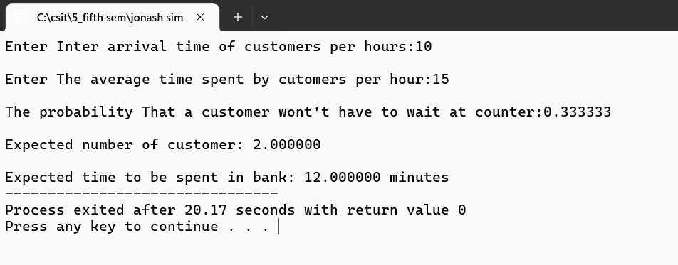


Lab No. 3
At the ticket counter of football stadium, people come in queue and purchase tickets. Arrival rate of customers is 1/min. It takes at the average 20 seconds to purchase the ticket.
WAP in C to calculate total time spent by a sports fan to be seated in his seat, if it takes 1.5 minutes to reach the correct seat after purchasing the ticket. if a fan comes exactly before 2 minutes before the game starts, can sports fan expects to be seated for the kick-off?
Source Code:
#include <stdio.h>

int main()
{
float arrival_rate = 1.0;
float service_time_sec = 20.0;
float service_rate = 60.0 / service_time_sec;
float travel_to_seat_min = 1.5;
float arrival_before_kickoff = 2.0;
float time_in_system_min = 1.0 / (service_rate - arrival_rate);
float total_time_min = time_in_system_min + travel_to_seat_min;

printf("Total time to reach seat: %.2f minutes\n", total_time_min);

if (total_time_min <= arrival_before_kickoff)
{
printf("Result: Yes, the fan will be seated before kick-off.\n");
}
else
{
printf("Result: No, the fan will miss the start of the game.\n");
}
return 0;
}

Output:
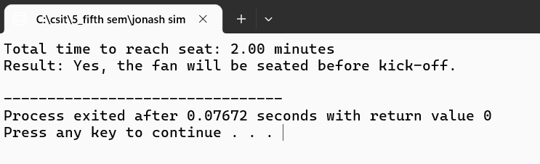


Lab No. 4
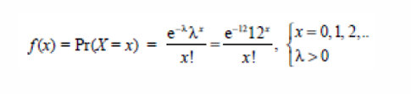
In a single pump service station, vehicles arrive for fuelling with an average of 5 minutes between arrivals. If an hour is taken as unit of time, cars arrive according to Poison’s process with an average of λ= 12 cars/hr. Write a C program to generate Poisson distribution for x = 0,1,2, …. 15.

Source Code:
#include <stdio.h>
#include <conio.h>
#include <math.h>
int main()
{
float l, m, p[16], pr, x, a, i;
int j;
printf("Enter arrival rate per hours:");
scanf("%f", &l);
for (x = 0; x < 16; x++)
{
a = 1;
for (i = 1; i <= x; i++)
{
a = a * i;
}
pr = (pow(2.71, -l) * pow(l, x)) / a;
printf("P(X=%f) = %f\n", x, pr);
}
}

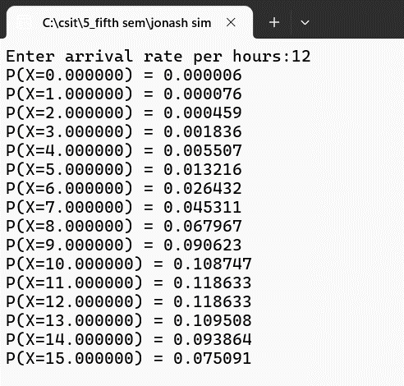
Output:



Lab No. 5
The probabilities of weather conditions (modelled as either rainy or sunny), given the weather on the preceding day, can be represented by a transition matrix:
0.9 0.1
0.5 0.5
The weather on day 0 is known to be sunny. This is represented by a vector in which the "sunny" entry is 100%, and the "rainy" entry is 0%: (1 0). Write a C program to find the weather of the next day by using Markov Chain Method.
Source Code:
#include <stdio.h>
#include <conio.h>
int main()
{
float transMat[2][2] = {0.9, 0.1, 0.5, 0.5}, vect[1][2] = {1, 0}, result[1][2];
int i, j, k;
for (i = 0; i < 2; i++)
{
for (j = 0; j < 2; j++)
{
result[i][j] = 0;
for (k = 0; k < 2; k++)
{
result[i][j] += vect[i][k] * transMat[k][j];
}
}
}
printf("\nWeather of next day using markov chain\n\n");
for (i = 0; i < 1; i++)
{
for (j = 0; j < 2; j++)
{
printf("%f\t", result[i][j]);
}
printf("\n");
}
return 0;
}

Output:
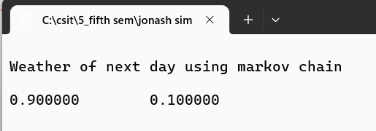


Lab No. 6
Q.N. 1: What is random number and what are its properties. WAP in C to generate 100 random numbers using Linear Congruential Method where X0=11, m=100, a = 5 and c = 13.
Source Code:
#include <stdio.h>
#include <conio.h>
#define SIZE 100
int main()
{
int x[SIZE], i;
int m = 100, a = 5, c = 13;
x[0] = 11;
for (i = 0; i < 100; i++)
{
x[i + 1] = (a * x[i] + c) % m;
}
printf("Generation of random numbers using linear congruential method:\n");
for (i = 0; i < 100; i++)
{
printf("%d\t", x[i]);
}
return 0;
}

Output:
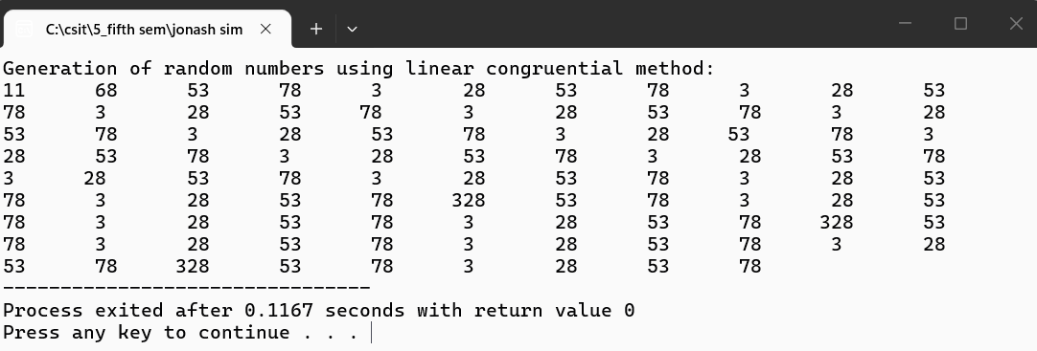

Q.N. 2: WAP in C to generate 100 random numbers using Multiplicative Congruential Method where X₀=13, m =1000, a = 15 and c = 7.
Source Code:
#include <stdio.h>
#define SIZE 100
int main()
{
long x[SIZE];
long m = 1000, a = 15, c = 7;
int i;
x[0] = 13;

for (i = 0; i < SIZE - 1; i++)
{
x[i + 1] = (a * x[i] + c) % m;
}
printf("Generated 100 random numbers:\n\n");
for (i = 0; i < SIZE; i++)
{
printf("%ld ", x[i]);
}
return 0;
}

Output:
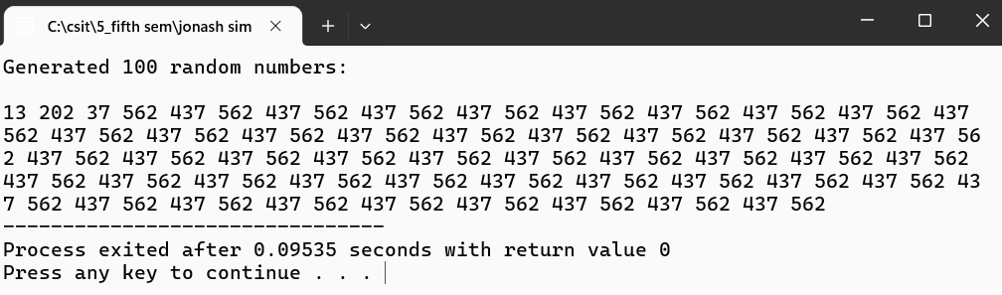



Lab No. 7
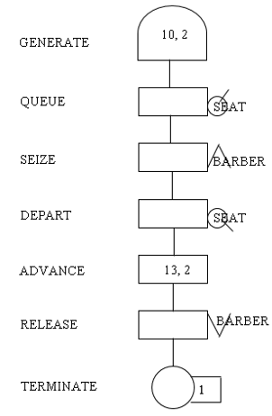
Create a GPSS model and program to simulate a barber shop for a day (9 a.m. to 4 p.m.), where a customer enters the shop every 10 ± 2 minutes and a barber takes 13 ± 2 minutes for a haircut.
Source Code:
GENERATE 10,2
QUEUE SEAT
SEIZE BARBER
DEPART SEAT
ADVANCE 13,2
RELEASE BARBER
TERMINATE 1
GENERATE 420
TERMINATE 1
START 1

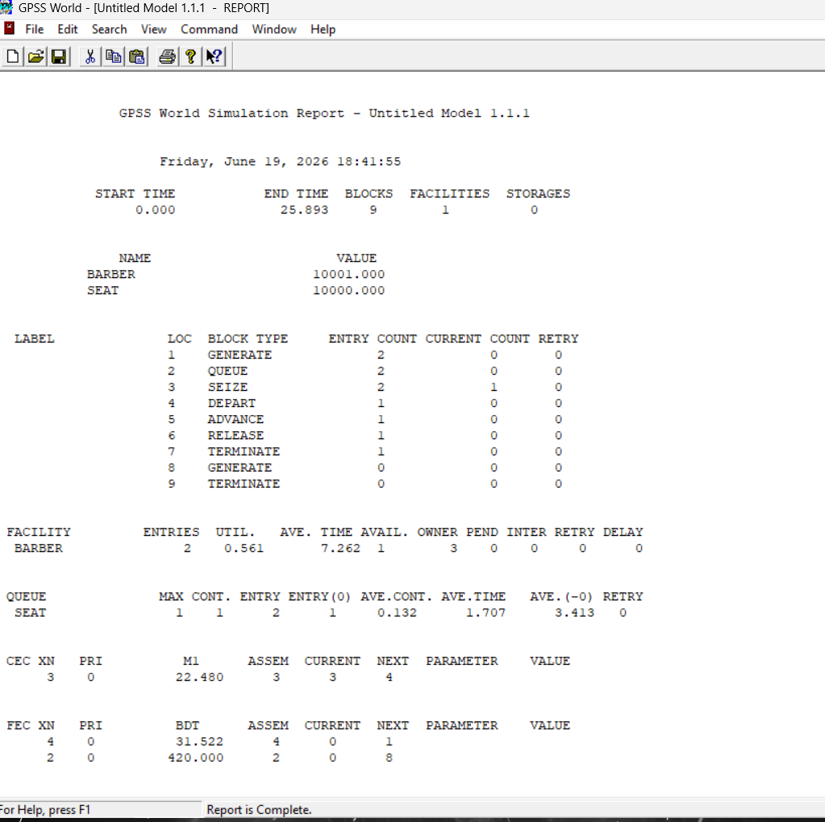
Output:



Lab No. 8
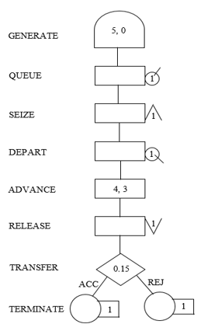
A machine tool in a manufacturing shop is turning out parts at the rate of every 5 minutes. When they are finished, the parts are sent to an inspector, who takes 4±3 minutes to examine each one and rejects 15% of the parts. Draw and explain a block diagram for it and write a GPSS program to simulate using the concept of FACILITY.
Source Code:
GENERATE 5,0
QUEUE INSQ
SEIZE INSPECTOR
DEPART INSQ
ADVANCE 4,3
RELEASE INSPECTOR
TRANSFER
0.15,REJ,ACC
ACC TERMINATE 1
REJ TERMINATE 1

Output:
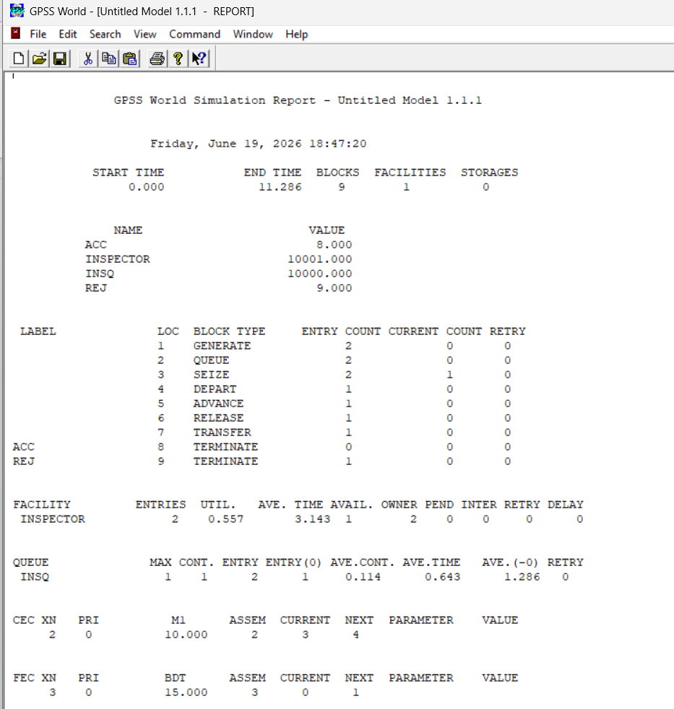



Lab No. 9
A GENERATE block is used to represent the output of the machine by creating one transaction every five units of time. A QUEUE block places the transaction in the queue and SEIZE block allows a transaction to engage a facility if it is available. If more than one inspector is available, the transaction leaves the queue which is denoted by DEPART block and enters into ADVANCE block. An ADVANCE block with a mean of 4 and modifier of 3 is used to represent inspection. The time spent on inspection will therefore be any one of the values 1, 2, 3, 4, 5, 6 or 7, with equal probability given to each value. Upon completion of the inspection, RELEASE block allows a transaction to disengage the facility and transaction go to a TRANSFER block with a selection factor of 0.15, so that 85% of the parts go to the next location called ACC, to represent accepted parts and 15% go to another location called REJ to represent rejects. Both locations reached from the TRANSFER block are TERMINATE blocks.

Source Code:
GENERATE 5,0,,,100
QUEUE INSQ
SEIZE INSPECTOR
DEPART INSQ
ADVANCE 4,3

RELEASE INSPECTOR
TRANSFER 0.15,REJ,ACC

ACC TERMINATE 1
REJ TERMINATE 1
START 100

Output:

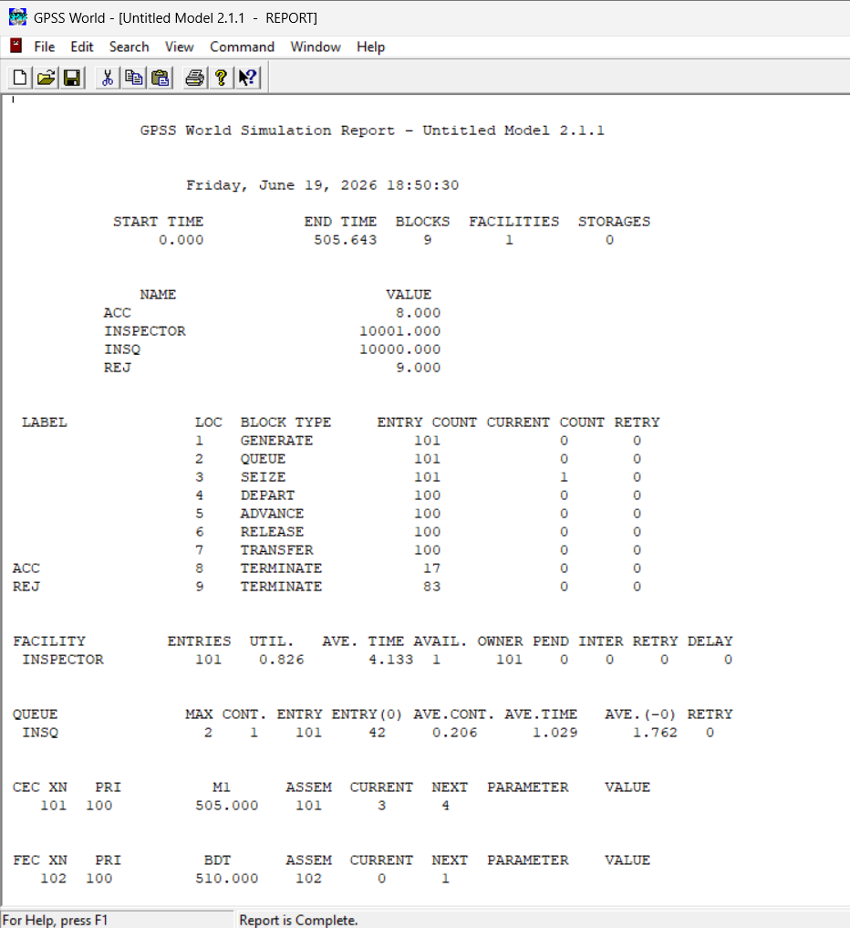



Lab No. 10
Parts are being made at the rate of one every 10 minutes. They are of two types; A and B. Mixed randomly with 10% being type B. Separate inspectors inspect each type. Inspection time for A is 6±2 minutes and for B is 10±2 minutes. Both inspectors reject 10% of parts. Simulate for 100 parts.
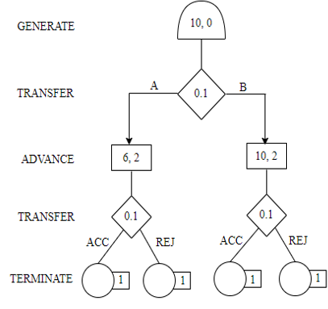
Source Code:
GENERATE 10,,,100
TRANSFER .10,TYPEB,TYPEA
TYPEA QUEUE AQUEUE
SEIZE INSPA
DEPART AQUEUE
ADVANCE 6,2
RELEASE INSPA
TRANSFER .10,REJA,ACCA

ACCA TERMINATE 1
REJA TERMINATE 1

TYPEB QUEUE BQUEUE
SEIZE INSPB
DEPART BQUEUE
ADVANCE 10,2
RELEASE INSPB
TRANSFER .10,REJB,ACCB

ACCB TERMINATE 1
REJB TERMINATE 1
START 100

Output:
